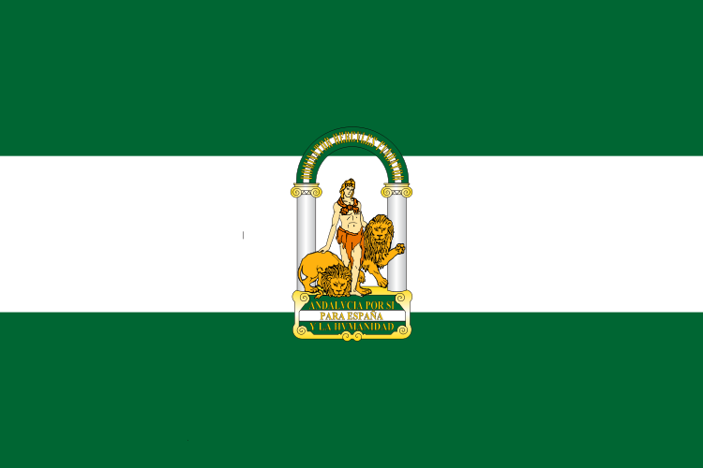

Hello . We are from Spain.

My Autonomous Community is Andalusia and it has nine provinces.
There capital is Seville. The municipality were I live is called Malaga.is may autonomous community we speak one language

My Autonomus Community

